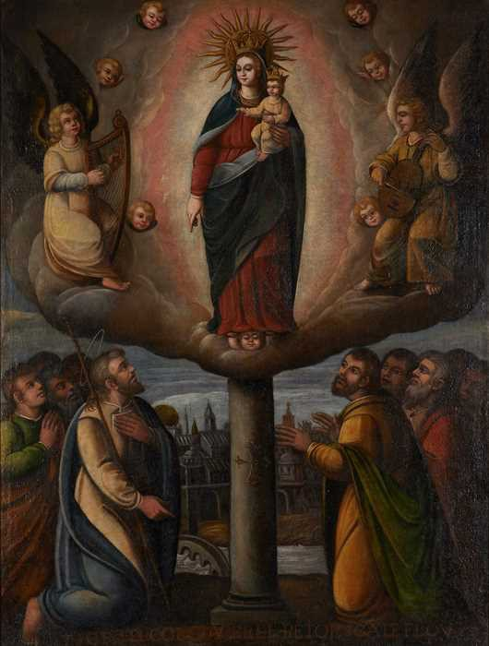

2003.003

*Our Lady of the Pillar of Zaragoza*

Unidentified artist Peru

Seventeenth or 18th century Oil on canvas, 58 x 50 inches

The inscription across the bottom is illegible.

According to pious tradition, the Virgin Mary appeared to the Apostle Saint James Major at Zaragoza, Spain on the shores of the Ebro River. She was accompanied by a choir of angels who

bore a jasper column upon which the Virgin wished an image of herself be placed and venerated. Local legend placed this event precisely on 2 January in the year 40 A.D. Documented history dates the Mozarabic sanctuary dedicated to Our Lady of the Pillar to the eleventh century, a more substantial Romanesque structure was built around 1140, and Zaragoza became a renowned pilgrimage site in the thirteenth century. In 1299 the advocation to Santa María del Pilar was officially documented for the first time. In 1515 King Ferdinand (after the death of his wife Isabel in 1504) authorized the building of a new Gothic building next to the old cloister and original chapel. A new chapel for the original pillar and image of the Virgin Mary was designed by Ventura Rodríguez in the second half of the eighteenth century.

The feast of Our Lady of the Pillar is today celebrated on October 12, which is also the date when Columbus first sighted *terra firma* in the New World, and so the cult has become associated with that discovery and Our Lady of the Pillar is considered the protectress of the New World (this is ahistorical, for October 12 was not a feast day dedicated to the Virgin of the Pillar in 1492).1 Certainly, the Virgin of the Pillar was the patron saint of all those who traveled from Zaragoza to the Americas, and her image is seen throughout the Spanish viceroyalties. In Mexico, José Borda dedicated an altar to her in Santa Prisca, Taxco and her appearance to Saint James is seen on the portal of the Franciscan church in Jalpan, a church dedicated to Santiago.2 In Ecuador, in the first quarter of the eighteenth century, Nicolás Javier Goríbar painted the Virgin Mary’s appearance to Santiago and pilgrims on the altarpiece dedicated to the *Virgen del Pilar* in the sanctuary of Guápulo, Quito. The composition of that painting is very similar to the Thoma version.

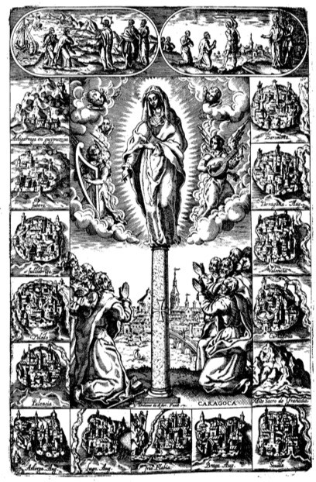

Fig. 1. Diego de Astor, *The calling of Santiago, his preaching in Spain, the foundation of churches, and his martyrdom*, from Mauro Castellá Ferrer, *Historia del Apóstol de Iesus Christo Sanctiago Zebedeo Patrón y Capitán de las Españas* (Madrid, 1610). Photo Yale University Library.

Both Goríbar and the unknown artist who created the Thoma painting had available to them many print sources for the iconography. Diego de Astor (fig. 1) illustrates the Virgin of the Pillar appearing to Saint James Major surrounded with images of the Spanish cities where he was thought to have evangelized in an engraving published in Mauro Castellá Ferrer’s *Historia del Apóstol de Iesus Christo Sanctiago Zebedeo Patrón y Capitán de las Españas* published in Madrid in 1610.3 The composition of the Thoma painting is similar to this print in many ways: the placement of the saint and accompanying pilgrims in the foreground with the Rio Ebro and the city of Zaragoza beyond, the angels playing a harp on the left and a stringed instrument on the right, and so on. There are differences, however, notably that the Peruvian artist has added the infant Christ in the arms of the Virgin Mary. In fact, a number of graphic sources were available from the early seventeenth century. In 1610 an image of the Virgen del Pilar came from the Zaragoza printer L. Sánchez; in that print the Virgin appears, with her celestial court of

angels, to Santiago and a group of pilgrims, just as she does in this painting. The same iconography is found in an engraving in a book published by A. Martín in Madrid in 1612. An engraving signed by J. Agüesca in 1644 and published in Huesca shows the appearance of the Virgin to pilgrims with the city of Zaragoza in the background. Of course, a number of these prints were published in Zaragoza, as the advocation to Our Lady of the Pillar gained fame.4 The study of Spanish colonial painting has focused on the use of art prints – individual sheets created by Italian engravers and in Flemish print workshops of the Wierix family and others.

However, Spanish American artists also had access to books printed in Spain and illustrated with engravings, the likely source of this painting in the Thoma collection.

The iconography of the Thoma painting is resolutely orthodox. The Virgin appears with musical angels at either side of the glowing mandorla that surrounds her, sustained by clouds upon a pillar bearing the cross of the order of Santiago. The saint himself, identified by his rod and his halo, kneels on the ground at her proper left. He is joined by the figures of other pilgrims, behind whom flows the Ebro River with the city of Zaragoza rising beyond it. The painting is so iconic (the way she holds the infant Christ and the gesture of her left arm and hand are very similar to the same details in a painting in Santa Clara, Tunja, Colombia) that it is difficult to guess its geographical source. However, the treatment of the faces of some of the pilgrims, and especially the faces of the angels playing the harp and violin, suggest the Cuzco school.

Besides the association of this image with Zaragoza, it is also possible that the painting was a private commission from a member of the Order of Santiago, to which many notables of Spanish colonial society proudly belonged.5

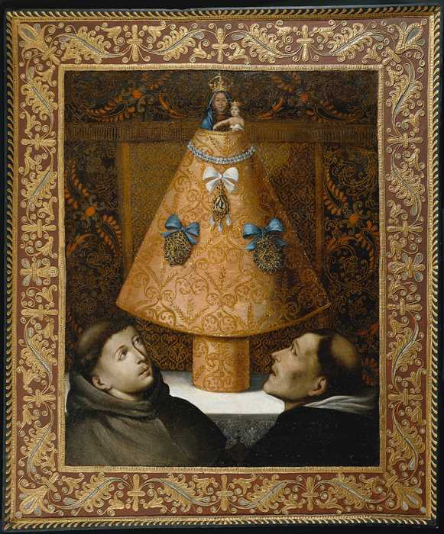

2004.004

Unidentified Artist

*Our Lady of the Pillar with a Franciscan and a Dominican Monk*

Possibly Lima (Peru)

18th century

Oil on canvas, 37 ¾ x 29 ¾ inches

According to tradition, the Virgin Mary, before her Assumption into Heaven, visited the Spanish city of Zaragoza to offer support to the evangelizing efforts of the Apostle James Major. She is said to have appeared, standing on a pillar and accompanied by angels, on 2 January of the year 40 A.D. That apparition is memorialized in an early fifteenth-century sculpture in the

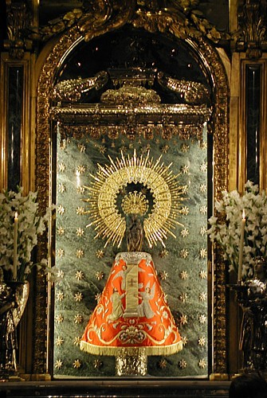*camerino* of the Santa Capilla in the Basílica del Pilar (fig. 2) in Zaragoza. The Virgin Mary cradles the naked Christ Child in her left arm; he holds a dove. The sculpture is placed atop a jasper column nearly two meters tall that is sheathed with gilt bronze. It is said that despite the considerable changes in the architecture and decoration of the church over time, the pillar itself has never been moved from its original location.

Fig. 2 Nuestra Señora del Pilar, Basílica del Pilar, Zaragoza.

The appearance of the Virgin to Saint James appears as a narrative scene in the other painting of the subject discussed above. In the present work, however, she is represented as a “dressed statue,” revered by two monks representing the Franciscan and Dominican orders. However,

Our Lady of the Pillar is not really a dressed statue, though she was cloaked in one of the many mantles that were donated to the image over the centuries and continuing even today.6

In his last will and testament dated 1504, Juan Benedic gave the Virgin 100 *sueldos* for the confection of a mantle. In 1577 a notarial document described 77 mantles then belonging to the image. The value of those mantles was estimated at between two and ninety *escudos*, suggesting that they were donated by a broad class range of the faithful. The oldest mantle in the collection, which continues in use today, dates from 1762, when it was made by the Capuchin nuns of Zaragoza.7 The mantles were originally placed high on the sculpture, revealing only the heads of the figures. Beginning in the eighteenth century, however, the mantles were placed low, at the feet of the Virgin and covering much of the pillar. This change of style suggests, therefore, a seventeenth-century date for the print source for the Thoma painting, in which the mantle is worn over the sculpture itself. The conical form of the mantle is sustained by a support over which the fabric is arranged. In practice, a complicated schedule concerning the placement and choice of the mantles is followed: on certain days of the month the image bears no mantle, on others the color of the mantle is governed by the liturgy of the day.

Hundreds of these mantles have been exquisitely made and generously donated by the faithful, and those no longer in use are distributed to churches and chapels all over the world. Some of them, called *mantos misioneros*, are sent to give solace to the sick and dying, to assure them of the consoling presence of the Virgin. In 1700 the Cabildo of the basilica sent a mantle to King Charles II of Spain during his final illness. In 1941, a mantle was dispatched to the regent María Cristina in Rome, where her son King Alfonso XIII lay on his deathbed. In 1969 the same mantle was sent to Lausanne, where Queen Victoria Eugenia died beneath its embrace.

A log in the basilica records the comings and goings of these mantles, and obituaries throughout the Catholic world sometimes mention that the deceased passed away “under the mantle of the Virgin of the Pillar.”

The mantle in the Thoma painting is painted to resemble pale silk embroidered with gold thread, its richness enhanced by the addition of two strands of pearls and three exquisite pendants attached with blue bows. The background, decorated with a delicate paisley pattern, seems intended to mimic *guadamacil*, the famed tooled and decorated Cordovan leather created in Spain and Portugal from the time of the Moorish Caliphate on the Iberian Peninsula.

*Guadamacil*, always an item of great luxury, antedated wallpaper as a wall covering. Another reflection of exquisite craftsmanship can be seen along the edge of the altar on which Our Lady of the Pillar appears: a short run of delicate lace. Lace imported from Flanders was much appreciated in the Viceroyalty of Peru, where large quantities of it were imported to lavish on the famously elaborate costumes of wealthy creoles. The frame around this composition is again a fictive recreation of *guadamacil*, in this case wrought by the careful application of twisted cord, which has then been gilded and painted. Beyond the border of this “frame” a series of comma- shaped brush strokes imitate a fringe lying on the very narrow border through which the actual wooden frame can be seen.

The two naturalistically painted heads of the monks, whose presence might have been overshadowed by all these impressive trompe l’oeil details, instead hold their own through an accurate sense of perspective and deftly handled chiaroscuro. This unique painting is truly a bravura performance by an unknown artist. Who that artist was and when it was painted are still open questions. The Spanish American origins of the painting are reinforced by its provenance in a private collection in Argentina and by the presence of monks from both the Franciscan and

Dominican orders. Their presence together in paintings is quite common in Spanish America, based in a providential interpretation of the missionary role of the religious orders in the “New World.” However, the choice of *guadamacil* as a background is otherwise unknown in Spanish colonial paintings, and the delicate rendering of the faces of the monks suggest the hand of a peninsular artist. It may have been painted by one of the mostly unidentified Spanish artists working in the Viceroyalty of Peru in the seventeenth century. In the late eighteenth century there were several Spanish artists working in Lima and this unique work may have been by one of them. This is not an aspect of Spanish colonial painting that has received the study that it is due. 8

Suzanne Stratton-Pruitt

1. Santiago Sebastián, *El barroco iberoamericano* (Madrid: Encuentros Ediciones, 1990), 17.
2. Ibid., 169.
3. This and other engravings in Castellá Ferrer’s book are discussed by Ana María Roteta de la Maza, *La ilustración del libro en la España de la Contrarreforma. Grabados de Pedro Ángeles y Diego de Astor 1588-1637* (Toledo: Instituto de Investigaciones y Estudios Toledanos, 1985), 167-292.
4. Blanca García Vega, *El grabado del libro español. Siglos XV-XVI-XVII,* 2 vols. (Valladolid: Institución Cultural Simancas, Diputación Provincial de Valladolid, 1974), 1:171.
5. Hector H. Schenone, *Iconografía del arte colonial. Los santos,* 2 vols. (Buenos Aires: Fundación Tarea, 1992), 2:712.
6. For detailed histories of the cult image and her mantles, see the websites provided by the Cabildo Metropolitano de Zaragoza: La Virgen del Pilar at <http://www.cabildodezaragoza.org/basilica/lavirgen.htm> and Mantos de la Virgen at <http://www.cabildodezaragoza.org/basilica/mantos.htm>
7. A painting that commemorates the establishment of the Conceptionist convent in Guatemala City, Guatemala, shows nuns of the order honoring Our Lady of the Pillar shown enclosed, from the waist down, with her mantle. See *Nuestra Señora del Pilar con Monjas Capuchinas* by Tomás de Merlo (18th century), Iglesia de San Miguel de Capuchinas, Archdiocese of Guatemala, Guatemala. Illustrated in *El país del quetzal. Guatemala maya e hispana*, exh. cat. (Madrid: Socieded Estatal para la Acción Cultural Exterior. Centro Cultural de la Villa de Madrid, 2002).
8. Ronda Kasl shared with us her observation that a print by Pedro de Villafranca was used by the unidentified painter as a model for the two friars in the Thoma painting. See Mark McDonald, *Pedro de Villafranca: Printmaker at the Court of Philip IV* (Madrid: Centro de Estudios Europa Hispánica, 2025), cat. no. 69, p. 267. The frontispiece was created by Villafranca for the first volume of the *Historia general de los religiosos descalzos del orden de los hermitaños del gran padre San Agustin de la Congregacion de España y de las Indias* (1664). The print was used again in the second volume (1681) and in the third, published in 1743. The central area of the frontispiece was inserted in each volume to identify the different authors and sponsors. Because the order evidently had a very light footprint in present-day Peru, it is likely that Villafranca’s print or a variation of it traveled to the Spanish Americas not in a book, but as one of the many engravings that found their way to the Americas and into Spanish colonial paintings. (See Fig. 3)

